

**CURRICULUM VITAE YASH PAL**

**STOREKEEPER**

**Current Location : Post Box : 112, Postal Code : 1393, Ruwi Sultanate Of Oman**

# 

+**968 -94230481, WhatsApp: +918780832486**

[**Paly7841@gamil.com**](mailto:Paly7841@gamil.com)



**CAREER OBJECTIVIES**

**WORKING EXPERIENCE**

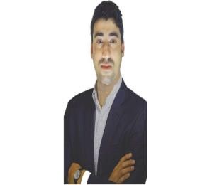

Seeking a challenging carrier in the ever- growing field of merchandiser. Best utilizing my experience, technical ability, analytical & problem solving skills. The job role manages timely receiving of materials/items at stock/stores yard in a construction site and inventory through computer system.

* Store Keeper

Oman National Engineering & Investment Co. (SAOG)

(Since Aug’ 2018 to till Date)

**TECHNICAL QULIFITION**

**EDUCATION QULIFICATION**

* **Information Technology** Pursue : Lovely Professional University, Jalandhar-Delhi

G.T. Road (NH-1), Phagwara, Punjab (INDIA) From: 2019-2023 Dec.)

* Passed High School In year 2010

From HP Board with 1st Division.

* Passed Intermediate In 2013 from

HP Board with 1st Division

* Diploma in industrial safety management from Ministry of Shipping, Patna Gai Ghat.
* Diploma of computer application.
* JavaScript
* Domestic Data Entry Operator

**RESPONSIBILITIES**

**SKILLS**

* Entering the incoming stocks and invoicing the sales order in ERP.
* Transfer stocks to separate locations.
* Stocks issuing to the branches and stock Receipt Voucher.
* Prepare a packing list in ERP and Excel.
* Handling purchasing orders.
* Ordering goods to a supplier and follow with ETA.
* Cash and cheque depositing in the banks.
* Creating PO in Oracle Software system.
* Operating system.
* Windows Packages.
* MS office, Excel A+.
* Communication Skills.
* Attention to details.
* Stress tolerance.

**HOBBIES**

**PERSONAL DETAILS**



Name : Yash Pal

Father’s Name : Inder Singh

Nationality : Indian

Date of Birth : 17-oct-92

Religion : Hindu

Gender : Male

Marital Status : Single Language Known : English, Hindi Passport Number : R5518235 Passport Issue Date : 22-nov-17

⇧

**Travel**

**Reading**

#  

**Writing**

**Music**

I Hereby declare that all the given particulars and details are true to the best of my Knowledge and belief and I am also willing to give my best for the company.